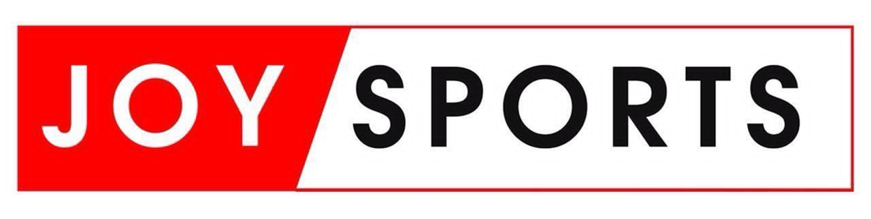

INVITATIONAL FOOTBALL TOURNAMENT 2025 Edition
9th August, 2025@ University of Ghana Stadium Legon

REGISTRATION FORM

(THIS FORM MUST BE COMPLETED IN DUPLICATE)
Name of Company: ....................................................................................................................................
Description of Business: ............................................................................................................................
Contact person: ..........................................................................................................................................
Contact Numbers: .......................................................................................................................................
Email Address: ............................................................................................................................................

PARTICIPATION FEE | BENEFITS | BENEFIT VALUE (GHC)
GHC 6,000.00 tax inclusive | - Five (5) minutes interview on JoyNews AM Show  - Five (5) slots of announcements on Joy FM  - Acknowledgement on radio and television as a participant on Joy FM, JoyNews and Joyprime  - One (1) article publication on myjoyonline.com  - Recording of bragging banter on client visit. | - 2,500  - 2,600  - 200,000  - 1,500

TERMS AND CONDITIONS:
- The Company shall be required to make an initial deposit of 50% of the total amount for participation upon execution of this form by registration.
- The Company shall be required to make a final payment of any amounts outstanding on or before a week to event.
- Upon an intention to withdraw from the Exhibition, the Company shall give not less than 30 days written notice of withdrawal.
- Failure to give the 30-day notice period shall result in the forfeiture by the Company of the 50% initial deposit paid upon execution of this form.
- A 30-day notice period shall entitle the Company to a full refund of any initial deposits made towards participation less a retention of 10% of the deposit as administrative charges.
- The Company shall be entitled to a full refund of any moneys paid towards the participation where the event fails to hold as scheduled as a result of default on the Organizer’s part.

SELECT TOURNAMENT GAMES FOR YOUR PARTICIPATION

ACTIVITY TYPE | YES | NO
MALE SOCCER TOURNAMENT
FEMALE PENALTY SHOOT CONTEST
TABLE TENNIS
UNISEX RELAY
LAWN TENNIS
UNISEX BASKETBALL
UNISEX SACK RACE
TAG OF PEACE
ARM WRESTLING
CEO‘s PENALTY SHOOT OUT
E - GAMES
WOMEN PENALTY SHOOT OUT
BOARD GAMES
UNISEX LIME & SPOON RELAY
SWIMMING

PARTICIPATION FEE GH¢ ……….

MOMO PAYMENT DETAILS | BANK PAYMENT DETAILS
0243430337  MULTIMEDIA GROUP LIMITED  (DANIEL BOIFIO) | ACCESS BANK  CASTLE ROAD BRANCH  0090101056951  Swift Code: ABNGGHAC  (MULTIMEDIA GROUP LTD)

For and on behalf of JOY FM For and on behalf of CLIENT

Name ……………………………… Name ………………………………

Title………………………………… Title…………………………………

Date………………………………… Date…………………………………

Signature……………………………. Signature…………………………….

