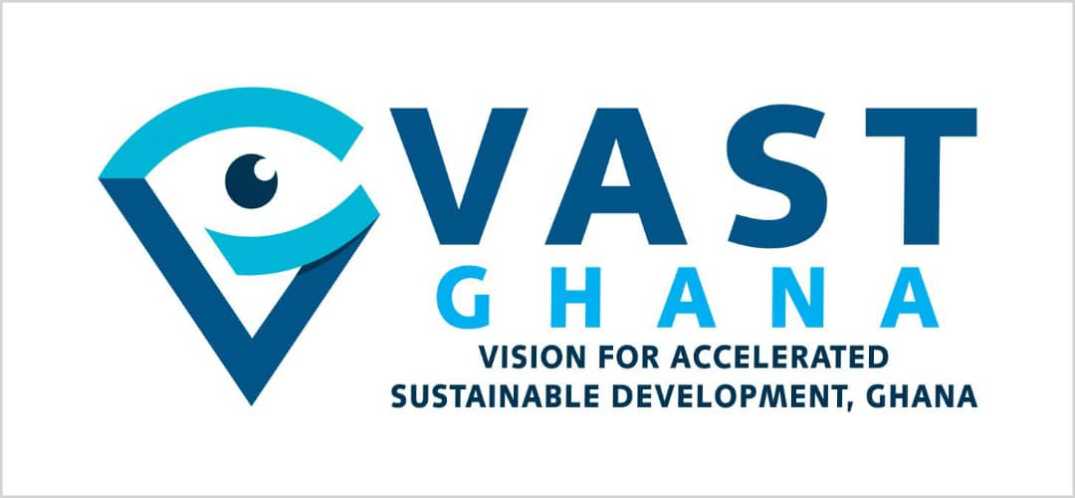
Press Release
1st October, 2025
Protecting Ghana’s Future:
Ghana must act now to protect children from electronic cigarettes to address the scary revelations in recent reports about its dire health consequences
Considering alarming revelations published by The Guardian on 19th August 2025, it is imperative that Ghana takes immediate steps to protect our children from the escalating dangers of vaping (electronic cigarettes). The report highlights that young people who use electronic cigarettes are almost three times more likely to start smoking cigarettes. It further links vaping to higher risks of asthma, respiratory infections, oral health problems, and mental health harms.
These findings reinforce what global research has long shown that vaping is not a harmless substitute for smoking. Instead, it often acts as a gateway, trapping young people into long-term nicotine dependence and making it harder to quit in adulthood. Echoing this, a separate Guardian-reported study in October 2024 revealed that one million people in England now vape (use electronic cigarette) despite never having been regular smokers—with vaping rates highest among 18 to 24-year-olds. This surge among non-smokers, many using high-strength nicotine disposables daily, underscores a growing public health crisis that mirrors the situation unfolding in Ghana and across Africa.
The Vision for Accelerated Sustainable Development (VAST-Ghana) welcomes this report and stresses that this global evidence reflects the realities in our communities particularly among young people. As The Guardian highlighted, the consistency of these risks is "striking," with experts warning that without action, vaping could entrench new generations into addiction.
It is crucial to reiterate that Ghana has a clear ban on recreational sales, advertising, and use of e-cigarettes. Despite this existing legal framework, vapes also known as electronics cigarettes (e-cigarettes) remain widely available through informal trade, social media platforms, bars, small shops and stores.
The situation is worse at the community level where many of these products mostly brightly colored, flavored, and marketed to appeal to children. International research shows that about 88% of young vapers use flavored products, and more than one in four vape daily clear signs of addiction. Although Ghana lacks large-scale data, community observations reveal a growing trend of flavored vapes among school children and young adults.
“Protecting Ghana’s children from nicotine addiction is non-negotiable,” “The Lancet review confirms what we already see here: young people are being hooked by vaping products, and many are moving to cigarettes to satisfy their addiction. Our laws are strong, but weak enforcement is failing the next generation. We need urgent action,” said Labram Musah, Executive Director of VAST-Ghana.
Global experts echo this urgency. Su Golder, Associate Professor in Health Science at the University of York and an author of the Lancet research, stated: “The consistency in the evidence is striking. Through multiple studies, young people who use e-cigarettes are more likely to smoke in the future. These findings support stronger public health measures to protect teens from the risks associated with vaping.
Similarly, Dr. Ronny Cheung of the Royal College of Pediatrics warned: “This study adds to the mounting evidence that youth vaping is a serious threat to health and wellbeing, with strong links to smoking and other harmful behaviors.”
The Ghana’s Food and Drugs Authority (FDA) has made it clear via a directive that Electronic Nicotine Delivery Systems (ENDS)—including vapes and e-cigarettes—are illegal for recreational use. However, non-tobacco products are permitted only under strict medical supervision for cessation. Illicit trade and unchecked online sales are undermining the Public Health Act and eroding Ghana’s hard-won tobacco control gains. These violations threaten public health, evades taxes and harms the economy. The World Health Organization (WHO) warns that sweet flavors and flashy designs are deliberate tactics to lure children into addiction. This makes strict enforcement even more urgent.
The harms of vaping extend beyond health. Disposable devices, often containing lithium-ion batteries, contribute to the growing e-waste crisis, raising fire risks in waste streams and undermining nation’s circular-economy goals. As Hazel Cheeseman, Chief Executive of Action on Smoking and Health, noted: “The rise in teen vaping in recent years is very concerning and needs urgent action from government. Some claim that vapes may help adults quit smoking, but this cannot justify their widespread use. They are addictive, harmful, and unsafe for children. No child should be exposed to them.
VAST-Ghana urges Ghanaian healthcare professionals, medical associations and researchers to speak out boldly on these issues. The organization encourages these professionals to share their documented frontline experiences with vaping-related cases, such as rising asthma diagnoses, respiratory infections, and nicotine dependencies among youth, to underscore the urgent need for intervention. Their evidence-based perspectives, rooted in local health data, will strengthen this call for action and mobilize communities to safeguard our children's health. Such action is deemed essential to prevent a future where these professionals foresee a generation burdened by chronic diseases, economic strain from healthcare costs, or irreversible environmental damage, urging a united effort to address these risks proactively. Bold and coordinated intervention by these professionals and stakeholders today will secure a healthier tomorrow for Ghana’s youth.
VAST-Ghana therefore demands that government agencies take swift and decisive action to strengthen the enforcement of existing regulations, and urge the government through its agencies take the following decisive action:
- Strengthen enforcement of the national directive on ENDS and launching joint market operations in major cities to confiscate illegal products and prosecute violators.
- Collaborate with online platforms and telecommunications companies to ban vape sales and related advertising.
- Intensify market swoops, border controls, online platform accountability, school protection measures, and penalties for violators.
- Launch a well-coordinated nationwide campaign with dedicated budget to increase awareness and educate the youth about the dangers of shisha and e-cigarettes.
- Leverage schools, media, and community platforms to counter industry misinformation and shift social norms
- Collaborate with the FDA, National Commission on Civic Education, the Ministry of Youth and Sports, Ministry of Gender, Children and Social Protection, CSOs and law enforcement to support the awareness campaign and crack down on illicit trade and ensure compliance.
- Conduct regular outreach in schools (primary, secondary and tertiary) and communities to assess awareness levels, confiscate illegal vapes, and apply penalties as per the Public Health Act, such as fines or seizures.
- Established a youth quit line, and national campaigns to counter industry marketing.
We cannot predict where these trends will lead us in the future—whether to a generation burdened by chronic diseases, economic strain from healthcare costs, or irreversible environmental damage. But we must rise now, united, to find solutions before it's too late. Bold action today will secure a healthier tomorrow.
“Ghana has the legal framework to stop this epidemic; a rapid enforcement drive, followed by sustained regulatory systems, will protect our children and secure our future.”
Ghana now faces a decisive moment. The evidence is clear, the laws exist, and the tools are available. What is required is bold, coordinated enforcement to stop the spread of vaping among children and young people. VAST-Ghana urges swift government action, backed by civil society and community support, to prevent this crisis from taking deeper root.

For more information, please contact:
Labram Musah
Executive Director
Vision for Accelerated Sustainable Development (VAST-Ghana)
labrammusah@gmail.com
0243211854

