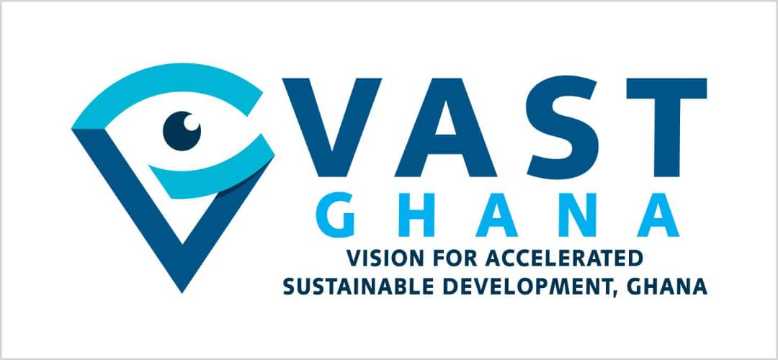
Press Statement
Ban Alcohol in Sachets to Safeguard Public Health
Ghana Must Emulate Nigeria’s Bold Policy Action on alcohol use
6th February, 2026

Vision for Accelerated Sustainable Development (VAST-Ghana), a public health advocacy organization, commends Nigeria and the National Agency for Food and Drug Administration and Control (NAFDAC) for their strong commitment to public health by enforcing the ban on sachet alcohol and small bottles under 200ml nationwide. Nigeria's decision to resume enforcement in January, 2026, despite alcohol industry opposition marks a vital precedent for public health in West Africa. The alcohol and beverage sector, including major groups like the Manufacturers Association of Nigeria (MAN), the Nigeria Employers’ Consultative Association (NECA), and industry associations such as the Distillers and Blenders Association of Nigeria (DIBAN), mounted significant resistance through protests at NAFDAC offices in Lagos and Abuja, public statements, and warnings of massive job losses, factory disruptions, economic fallout, and threats to investments. They argued that the move was hasty, contradicted prior government directives, and would not effectively curb underage drinking. VAST-Ghana applauds NAFDAC's unshakable resolve amidst intense industry pressure in their stance of choosing public health over profit-making ventures.

By acting decisively, NAFDAC has shown that safeguarding the public, especially children and minors, from early alcohol exposure requires strong regulatory enforcement rather than just words. These small, inexpensive, and easy-to-hide packages make high-strength alcohol (often 43% or more) easily accessible to underage users, including school children who can conceal them in pockets. This situation leads to alcohol abuse, addiction, physiological damage such as liver damage, even from small amounts, and long-term health problems, as early exposure is particularly harmful to developing bodies.
NAFDAC’s ban directly tackles the 'affordability gap' exploited by the alcohol industry. It is important to recognize that NAFDAC, like Ghana’s Foods and Drugs Authority, functions as a regulatory agency with the authority to create and enforce safety standards. VAST-Ghana points out that the Ghana FDA already has the legal authority under the Public Health Act (Act 851) to enforce a similar ban through administrative orders. This method could avoid lengthy parliamentary debates, which the industry often uses to delay action. The Ghana FDA has activated the mandate ascribed to them via the Act 851 to ban well-known personalities from alcohol advertisement, restrict adverts on radio and television, among others. We commend those bold actions, however the call by CSOs to ban alcohol in sachets and miniature bottles is long overdue, and the time to act is now.
VAST-Ghana further commends the recent announcement by Honourable Mahama Ayariga, Majority Leader and Leader of Government Business in Parliament, regarding the Government’s plan to introduce the Alcohol Control Regulations Bill in Parliament. The Majority Leader at a parliamentary leadership media briefing on 3rd February, 2026, stated that the proposed legislation aims to protect public health, particularly young people, by curbing excessive exposure to alcohol promotions. The Bill will set clear guidelines for marketing alcohol products, including restrictions on broadcast times, sponsorships, and promotional activities that target vulnerable groups, including children.
We urge the Government and FDA to build on this momentum by urgently banning alcohol in sachets and miniature bottles while also supporting the finalization of the alcohol regulations. This will ensure that Ghana catches up with regional leaders like Nigeria, Uganda, and Malawi in protecting its citizens from predatory alcohol marketing and high-risk packaging.
Ghana currently finds itself at a pivotal juncture in the fields of public health and development. The widespread availability of sachet alcohol has rendered highly potent spirits perilously affordable and accessible, particularly to vulnerable groups such as children and low-income communities. Ghana is not alone in this struggle, but we are falling behind our neighbours. Countries across Sub-Saharan Africa have recognized that sachet alcohol is a primary driver of poverty and addiction. Uganda implemented a successful ban in 2019, which significantly reduced the visibility of high-potency spirits in public transport terminals. More recently, in 2025, Malawi’s bold ban was hailed by the University of Stirling and the WHO as “a blueprint for public health advances in Africa.” These countries have proven that a ban does not destroy the economy; rather, it shifts consumption toward safer, regulated formats while drastically reducing the state's expenditure on alcohol-related healthcare and road traffic accidents.
According to the 2025 Alcohol Market Report, while the global alcohol market is contracting, Ghana’s sector is projected to grow by 13% annually. This growth is not a sign of economic health; it is a symptom of a deepening addiction crisis fueled by sachets and miniature bottles priced as low as 3.00 Ghana cedis ($0.27) and 5.00Ghana cedis ($0.46), respectively, making them more accessible to a 10-year-old than a nutritious meal. Globally, the WHO identifies alcohol as a causal factor in over two hundred (200) diseases and attributes approximately three million deaths each year to its use.
Our call is grounded in the WHO’s Global Strategy to Reduce the Use of Alcohol and the SAFER technical package. Specifically, we demand the implementation of the 'S' pillar—Strengthen restrictions on alcohol availability. The WHO identifies the regulation of physical availability, including measures to address high-risk packaging as 'best buy' interventions.
Movendi International has repeatedly exposed the industry's “playbook” of using small packaging to bypass minimum unit pricing and target low-income populations. By removing these 'pocket-sized' toxins, Ghana can align with international best practices and fulfill its commitment to SDG Goal 3.
Recent research published in BMC Public Health (May 2025) reveals a terrifying trend: alcohol is now the most used substance among Ghanaian students, with initiation ages dropping as low as 10 years. The normalization of sachet alcohol in transport terminals/parks, community gatherings, and even near schools creates a toxic environment for our youth and children. This is not just a health issue; it is a threat to our national security and future human capital. A nation that allows its children to be targeted by predatory marketing is a nation sacrificing its future.
As a matter of urgency, VAST Ghana makes the following demands and call to action to the Government of Ghana through the FDA:
1. The Food and Drugs Authority to exercise its regulatory power to immediately ban the production and sale of alcohol in sachets and PET bottles.
2. Officially integrate the proven SAFER technical package into national policy framework. SAFER is an acronym for five high-impact, cost-effective interventions: (Strengthen restrictions on alcohol availability, Advance and enforce drink-driving countermeasures, Facilitate access to screening and treatment for alcohol use disorders, Enforce bans or restrictions on alcohol advertising, sponsorship, and promotion, and Raise prices on alcohol through taxation and pricing policies).
3. Establish and enforce stringent conflict-of-interest guidelines to effectively limit/exclude alcohol industry actors from interfering in public health policy-making processes.
4. Finalise and adopt the National Alcohol Regulations.
VAST-Ghana urges the Government of Ghana, the Ministry of Health, the FDA, Parliament, and all relevant stakeholders to adopt a bold, evidence-based stance in this regard. Protecting public health through decisive policy is not punitive; it is preventive, progressive, and pragmatic. The health of Ghanaians is the foundation of the nation’s productivity, and no economic argument should be strong enough to undermine that. By banning sachet alcohol and adopting comprehensive alcohol control measures, Ghana can build a healthier, wealthier, and more resilient future.
For more information, please contact:
Labram Musah
Executive Director
Vision for Accelerated Sustainable Development (VAST-Ghana)
labrammusah@gmail.com - 0243211854

