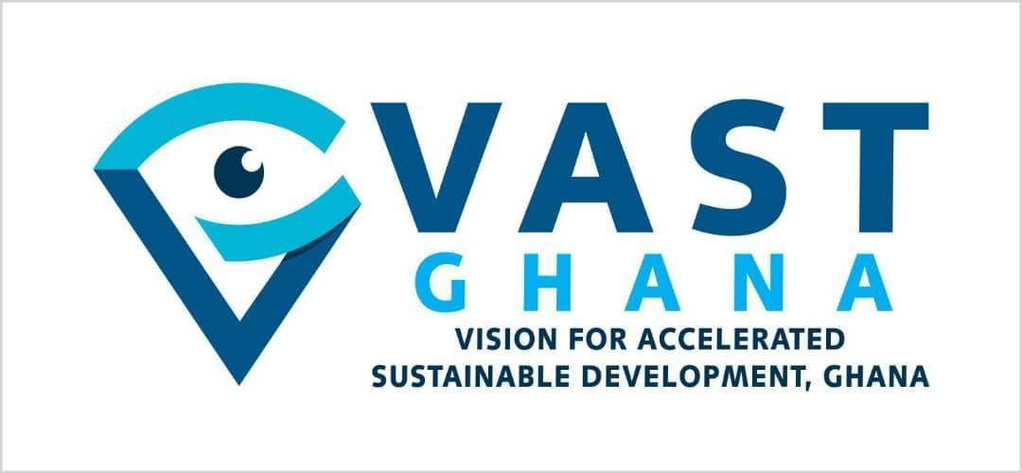
Press Statement:
New Global Evidence Reinforces Need for Stronger Alcohol Policy Action in Ghana. Study title: “Alcohol Intake and Health Study”
10th July 2026

Vision for Accelerated Sustainable Development Ghana (VAST Ghana) is calling on government, policymakers, health professionals, and the public to urgently recognise new scientific evidence showing that alcohol-related health risks begin at lower levels of consumption than previously believed and rise sharply beyond one drink per day. These findings underscore the pressing need to strengthen alcohol policies and intensify public awareness efforts to reduce preventable harm in Ghana.
The study, published on 8 June 2026 in the Journal of Studies on Alcohol and Drugs (Vol. 87, No. 4, pp. 621–638), found that health risks increase progressively with consumption, while any supposed benefits of moderate drinking are far less certain than once assumed. Researchers concluded that “health risks increase more sharply after one drink per day", directly challenging long-standing narratives that moderate alcohol use is harmless or beneficial.
This evidence is consistent with the World Health Organization’s 2023 declaration that no level of alcohol consumption can be considered safe for health. The WHO emphasised that risk to the drinker begins with the very first drop and rises with every additional drink. Taken together, the two reports reinforce a clear and consistent scientific position; there is no safe threshold for alcohol consumption, and the associated health risks outweigh any perceived benefits of light or moderate drinking.
The findings, recently circulated through public health platforms including Movendi International, a global alcohol policy organisation, add to a growing body of independent scientific evidence demonstrating that alcohol consumption carries substantial health risks, including cancer, cardiovascular disease, liver disease, injuries, and other non-communicable diseases (NCDs).
This publication arrives at a critical moment globally, amid ongoing debate over alcohol guidelines, industry influence, and the role of independent science in shaping public health policy. It follows reporting by STAT News, Scientific American, NBC News, and other international outlets raising concerns that important alcohol research has been delayed or sidelined despite its public health significance. Of particular note is the Interagency Coordinating Committee on the Prevention of Underage Drinking's (ICCPUD) own scientific review of alcohol and health: a former U.S. federal health official has said this review was delayed and ultimately excluded from the latest U.S. Dietary Guidelines process, in favour of a rival, industry-friendlier review.
This evidence has also been disseminated through public health platforms, including Movendi International, a global alcohol policy organisation, and adds to a growing body of independent scientific research linking alcohol consumption to cancer, cardiovascular disease, liver disease, injuries, and other non-communicable diseases (NCDs). Movendi International has described the study as a landmark contribution to understanding alcohol harm and has voiced concern over attempts by allies of the alcohol industry to undermine or suppress independent research. According to Movendi, the findings reinforce what public health experts have long maintained: Alcohol is not an ordinary commodity, and policies governing its marketing, availability, and affordability must be guided by health evidence rather than commercial interests. For Ghana, this calls for a serious reassessment of the national alcohol policy environment.
Alcohol consumption remains a major but often under-recognised contributor to the country’s growing burden of non-communicable diseases. As Ghana continues to grapple with rising cases of hypertension, stroke, cardiovascular diseases, cancers, liver and kidney diseases, mental health conditions, and road traffic injuries, alcohol-related harm demands greater policy attention.
Ghana’s most recent STEPS Survey, conducted with WHO support in 2023, found that 22.6% of Ghanaian adults are current drinkers, rising to 30.6% among men. The Mental Health Authority recorded 3,765 alcohol-related mental health disorders in 2023 alone. NCDs, to which alcohol is a major contributor, account for nearly 45% of all deaths in Ghana. indicate that alcohol consumption remains widespread, particularly among adults and young people. While public awareness efforts have increased over the years, the normalisation of alcohol use through advertising, sponsorships, digital marketing, and social influence continues to shape consumption patterns.
The challenge is not limited to individual behaviour. It is also rooted in the environments and commercial systems that encourage and sustain harmful consumption.
The alcohol industry continues to market products aggressively, while the health, social, and economic consequences are borne by individuals, families, communities, and the national health system. Every alcohol-related cancer diagnosis, road crash, liver and kidney disease cases, and household pushed into financial hardship reflects a preventable burden extending far beyond the individual consumer.
As Ghana seeks sustainable solutions to its NCD crisis, stronger action is needed to address the commercial determinants of health that drive alcohol-related harm.
VAST Ghana, therefore, calls on government, policymakers, public health institutions, and development partners to:
• Integrate alcohol harm prevention more explicitly into Ghana’s national NCDs response, recognising alcohol as a major and preventable risk factor for disease and injury.
• Strengthen and enforce comprehensive restrictions on alcohol advertising, sponsorship, and digital marketing, particularly those targeting young people.
• Expand public education and risk communication on the links between alcohol consumption and cancers, cardiovascular diseases, liver disease, mental health conditions, and injuries.
• Protect public health policy development from commercial interference and other vested interests and ensure transparency in engagements with the alcohol industry.
• Consider and implement fiscal and regulatory measures, including health taxes, health warnings, and aggressive marketing, to reduce alcohol consumption and generate domestic resources for NCD prevention and health promotion.
The conversation on alcohol must move beyond industry narratives and focus on health outcomes. Just as Ghana has made important progress in tobacco control through evidence-based policies, there is an opportunity to apply similar public health principles to alcohol harm prevention.
The question is no longer whether alcohol contributes to disease and premature death. That connection is well established in global and national research. The more pressing issue is whether policy responses are keeping pace with what the science already shows and whether enough is being done to reduce preventable harm in our communities.
VAST Ghana remains committed to advancing practical, evidence-based public health action that reduces avoidable disease, protects young people from harmful exposure, and supports healthier environments for current and future generations.
A copy of the report can be found here

Media Contact

Jennifer Maame Ama Owusu
Communications Manager
Vision for Accelerated Sustainable Development Ghana, VAST Ghana
jenniferowusu@vastgh.org
+233208013990

